Solving Green Vehicle Routing Problem Using Heuristic Approach

By

**Md. Ahsan Habib**

**Roll**: 1507082



**Supervisor:**

Dr. Md. Aminul Haque Akhand

Professor

Department of Computer Science and Engineering

Khulna University of Engineering & Technology Signature

**Department of Computer Science and Engineering**

**Khulna University of Engineering & Technology**

**Khulna 9203, Bangladesh**

1. **Introduction**

The Vehicle Routing Problem (VRP) is a [combinatorial optimization](https://en.wikipedia.org/wiki/Combinatorial_optimization) and [integer programming](https://en.wikipedia.org/wiki/Integer_programming) problem. It’s an NP-Hard problem. The goal of VRP is to find optimal routes for multiple vehicles visiting a set of customers or nodes. The routes with the minimum total distance are called optimal routes. In VRP only conventional vehicles are used. As the conventional vehicles emerges much Carbon Dioxide (*CO2*) gas, we consider here Green Vehicle Routing Problem (GVRP), which is variant of VRP, is multi-objective optimization and integer programming problem, uses both conventional vehicles and alternative fuel vehicles (AFVs). We consider electrical vehicles as alternative fuel vehicles. In case of electrical vehicles, no emission will be emerged.

1. **Related Study**

|  |  |  |
| --- | --- | --- |
| Authors & Year | Title of Paper | Contribution |
| Costa et al., 2018 | A Genetic Algorithm for a Green Vehicle Routing Problem | Minimizes the CO2 emissions per route |
| Macrina et al., 2019 | The green mixed fleet vehicle routing problem with partial battery recharging and time windows | Considers both Conventional and Electrical Vehicles |
| Koc and Karaoglan, 2015 | The Green Vehicle Routing Problem: A Heuristic Based Exact Solution Approach | Considers limited driving range of vehicle with limited refueling infrastructure |
| Jabir et al., 2015 | Multi-objective Optimization Model for a Green Vehicle Routing Problem | Minimizes of Carbon Dioxide (CO2) emission |
| Felipe et al., 2014 | A Heuristic Approach for the Green Vehicle Routing Problem with Multiple Technologies and Partial Recharges | Considers only Electrical Vehicles |
| Figliozzi, 2011 | The Recharging Vehicle Routing Problem | Calculates amount of fuel spent |
| Laporte, 2011 | The Pollution-Routing Problem | Considers polluting emission impact |
| Demir et al., 2014 | The Bi-objective Pollution-Routing Problem | Minimize both fuel consumption and driving time |
| Schneider, 2015 | Routing a Mixed Fleet of Electric and Conventional Vehicles | Considers both Conventional and Electrical Vehicle |

1. **Methodology**

We use three different phases to solve Green Vehicle Routing Problem. They are:



* 1. **Clustering**

As we discussed that two types of vehicles are used to solve GVRP, it is needed two clusters named as *C* and *E* which are served by the conventional vehicles and electrical vehicles respectively. In order to create cluster *C* and cluster *E*, two scores called *PC* and *PE* are used. They both have range in 1 to 10 (1 *<= P*C, *PE <=* 10).

The first score *PE* is calculated using the following equation.

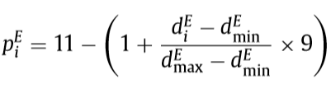

Where,

* *diE* is the distance between the customer *i* and the barycenter *be* of the set *E*
* *dmin*is the distance between *be* and nearest customer
* dmax is the distance between *be* and farthest customer

The second score *PC* is determined using the following equations.

 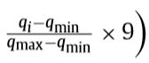

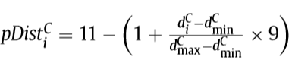

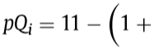 

Where,

* *diC* is the distance between the customer *i* and the barycenter *bc* of the set *C*
* *dmin*is the distance between *bC* and nearest customer
* *dmax* is the distance between *bC* and farthest customer
* *qmin* and *qmax* are the smallest and largest customer demands respectively

After this step, all customers are either assigned to cluster *C* or cluster *E.*

* 1. **Route Assignment**

To insert an unserved customer into the current route, we need:

* Best position
* Best customer

To calculate *best position* inside the current route, the following equation is used:



Where,

* *u* is the unserved customer
* *i(u)* and *j(u)* are two adjacent customers into the current route

To determine *best customer* from the unserved customers, the following equations are used:



Where,

* *u* is the unserved customer
* *i(u)* and *j(u)* are two adjacent customers into the current route

In case of inserting unserved customer into conventional routes, it is necessary to verify the feasibility of the new solution. Unserved customer and the position are determined by the given equations. If the insertion is infeasible, a new route will be created. Otherwise, the customer will be served by the ECVs.

On the other hand, in case of electrical routes, if some customers belonging to cluster C are not served by conventional vehicles, the are inserted in cluster E. The position and the customer are calculated by the given equations. It the insertion of unserved customer satisfies the capacity and time windows constraints, then the customer can be added to the route.

After completing this step, we find an initial feasible solution.

* 1. **Improvement Heuristic**

Local Search and Perturbation are applied to make the initial solution better.

* + 1. **Local Search**

The strategies used by Local Search are described in followings:

1. Change of customer belonging to conventional routes
2. Change of customer belonging to electrical routes
3. Change of customer belonging to the conventional and electrical routes

These strategies are clearly depicted in following Fig. 1.

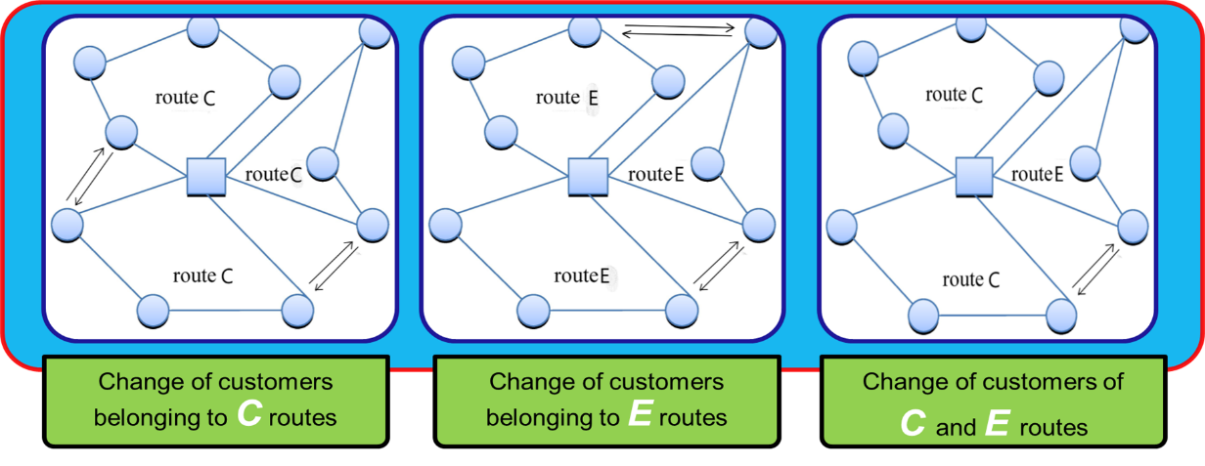

Fig. 1. LS strategies.

In Local Search procedure, worsening of the solutions are not accepted.

* + 1. **Perturbation**

The perturbation is performed by using the same strategies as those implemented in the Local Search. But, in case of perturbation, worsening of the solutions are accepted in order to better explore the neighborhood.

1. **Result**

Here, we used modified Solomon, 1987 instances and these are solved by CPLEX 12.5, an optimization software package, which produce the optimal solution. As CPLEX can only solve the problem with small customers, 5 and 10 customers are considered. Here, α is determined how much emissions we are going to accept. The following Table 2 shows the comparison with expected result and optimal result.

**Table 2.** Average percentage cost variation and speedup.

|  |  |  |  |  |  |  |
| --- | --- | --- | --- | --- | --- | --- |
| Class | α = 0.25 | | α = 0.50 | | α = 0.75 | |
| Cost Variation (%) | Speed Up | Cost Variation (%) | Speed Up | Cost Variation (%) | Speed Up |
| | N | = 5 | 5.25% | 1.46 | 9.32% | 1.05 | 9.30% | 1.11 |
| | N | = 10 | 13.67% | 12.81 | 12.93% | 8.96 | 15.67% | 4.07 |
| Average | 9.46% | 7.13 | 11.13% | 5.01 | 12.48% | 2.59 |

1. **Future Work**

* Use hybrid vehicles (conventional and electrical engine)
* Use bi-fuel vehicles (gasoline and CNG/LPG/Hydrogen)
* Try to minimize emissions
* Make the used algorithms more efficient

1. **Conclusion**

* Although GVRP is NP-hard optimization problem, we solved it efficiently through heuristic.
* By this heuristic, many real-world and large-scale problem can be solved.

**References**

1. <https://en.wikipedia.org/wiki/Vehicle_routing_problem>
2. Bektas¸ T., Laporte, G., 2011. The pollution-routing problem. Transp. Res. Part B 45, 1232–1250.
3. Conrad, R.G., Figliozzi, M.A., 2011. The recharging vehicle routing problem. In: Doolen, T., Van Aken, E. (Eds.), Industrial Engineering Research Conference. Reno, Nevada.
4. Christofides, N., The vehicle routing problem, Revue Fran¸caise D’Automatique, D’Informatique et de Recherche Op´erationnelle. Recherche Op´erationnelle 10 (1976), pp. 55–70.
5. Baldacci, R., P. Toth and D. Vigo, Exact algorithms for routing problems under vehicle capacity constraints, Annals of Operations Research 175 (2010), pp. 213–245.
6. Baldacci R, Mingozzi A, Roberti R (2012) Recent exact algorithms for solving the vehicle routing problem under capacity and time window constraints. Eur. J. Oper. Res. 218(1):1–6.
7. Artmeier A, Haselmayr J, Leucker M, Sachenbacher M (2010) The shortest path problem revisited: Optimal routing for electric vehicles. KI 2010: Advances in Artificial Intelligence, Lecture Notes in Computer Science, Vol. 6359 (Springer, Berlin), 309– 316.